# Login page

* Every user must login to the Service Portal in order to use the functions in the portal.

## 1.Login screen

Enter user credential and click “**Sign in**”

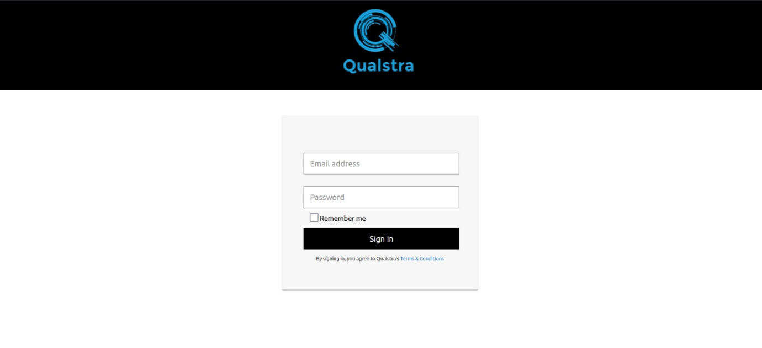

**Login Successful - Welcome Page**

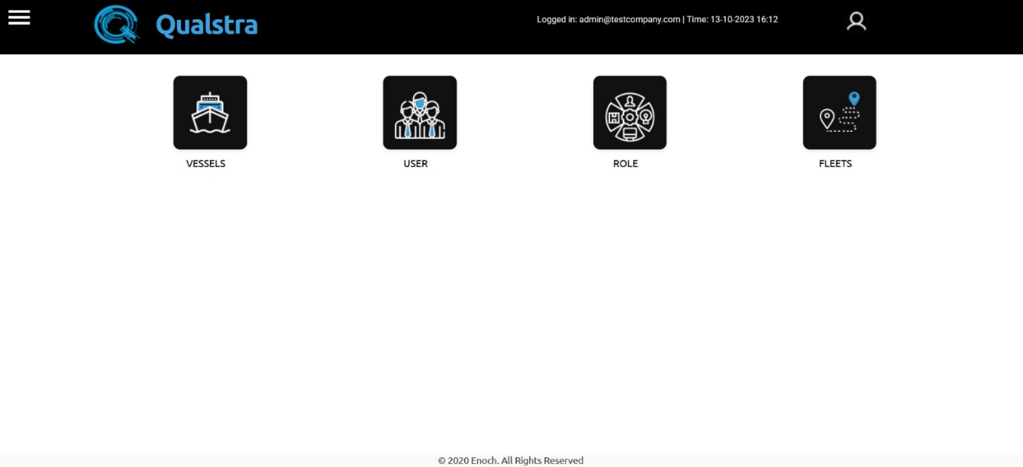

**Login Failure Page**

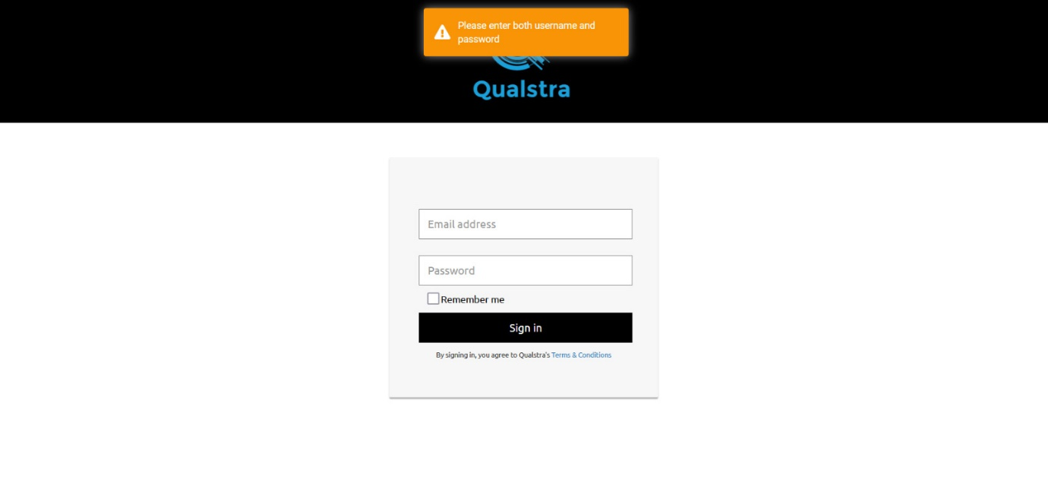

## **2.Fields**

* **Username:** Login Mail ID
* **Password:** Login Password

## **3.Procedures**

* To log into the system, enter your login ID in **Mail ID** and login password in **password** fields
* Then Click “**Sign in**”

# Vessels

* Click the Vessels Icon to enter to vessels page



**To Add New Vessel**

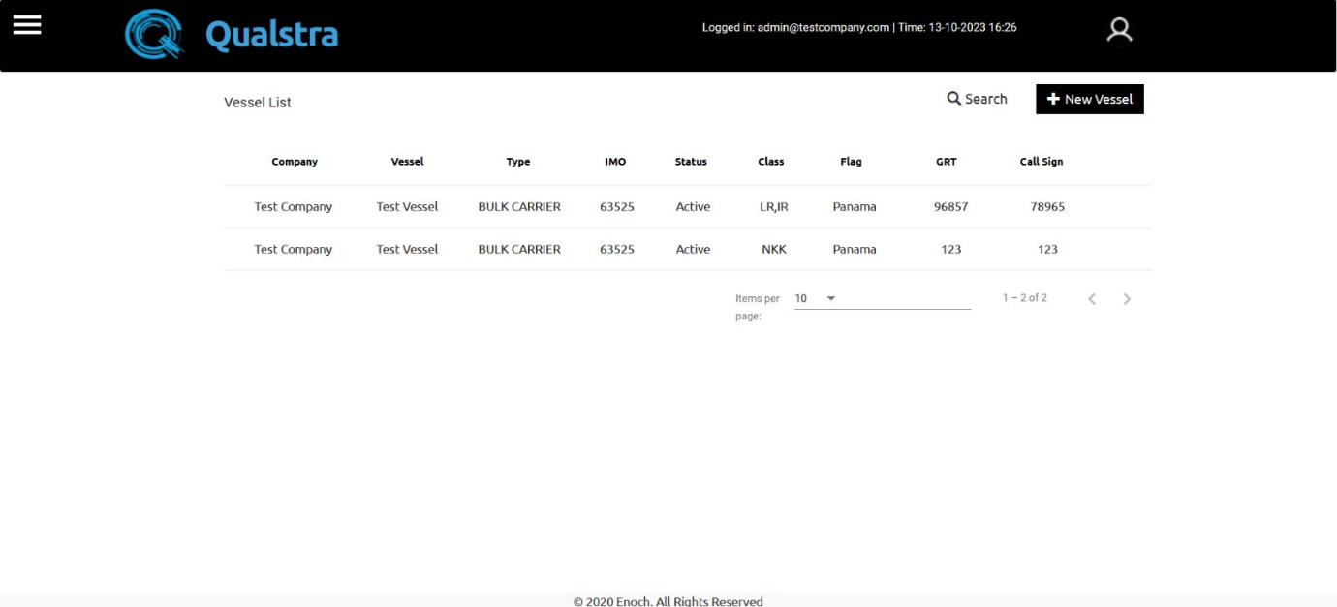

* Click the +New Vessel Button.
* After Clicking, you will get this screen.

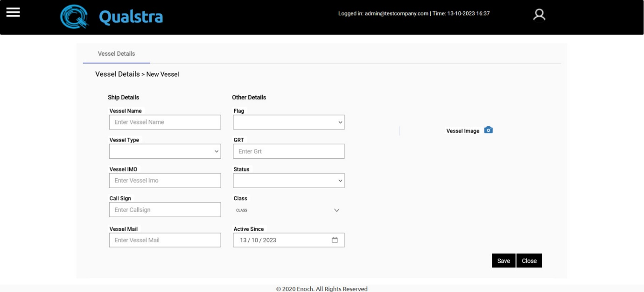

* Enter the require fields of the vessel
* Add vessel image
* After entering require details click the save Button.

**To Go Home Page**

* Click the three-line Button at right top corner.



* You will have a Dropdown option.
* Click the Home Button.

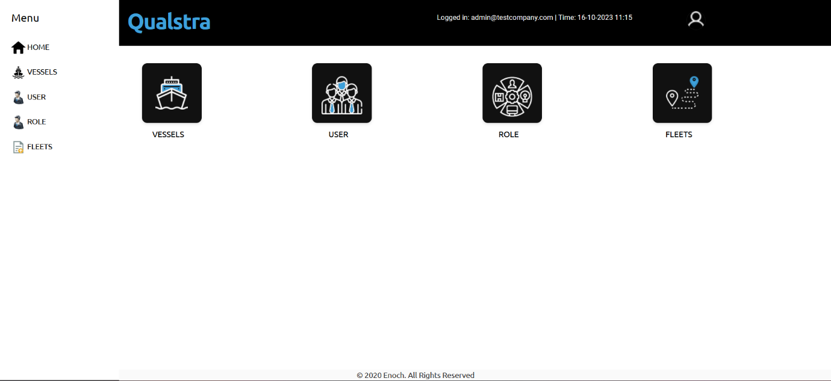

* You will get home page.



# User

* Click the user Icon to enter to user page



**To Add new User**

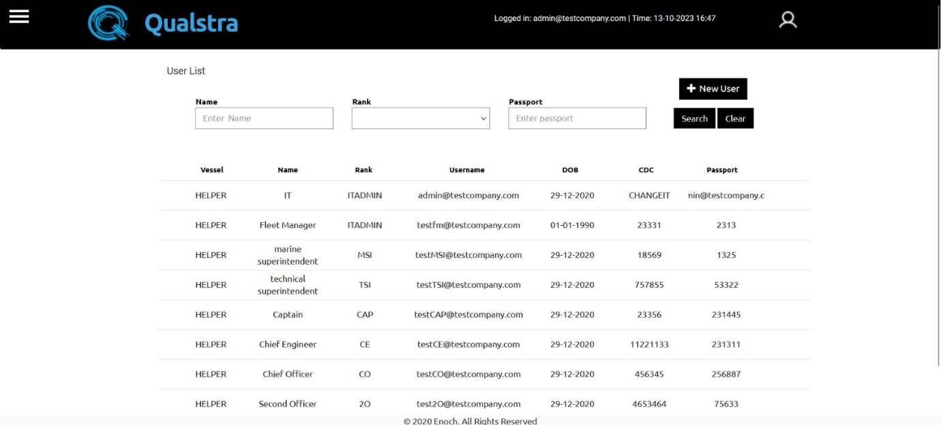

* Click the +New User Button.
* After Clicking, you will get this screen

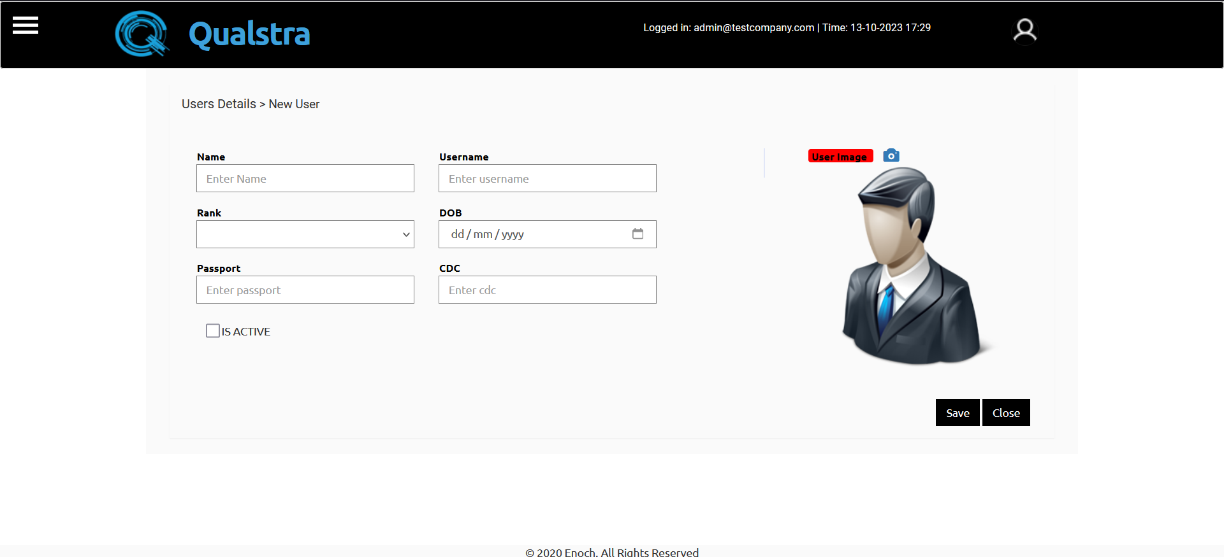

* Enter the require fields of user
* Add user image
* After entering require details click the save Button.

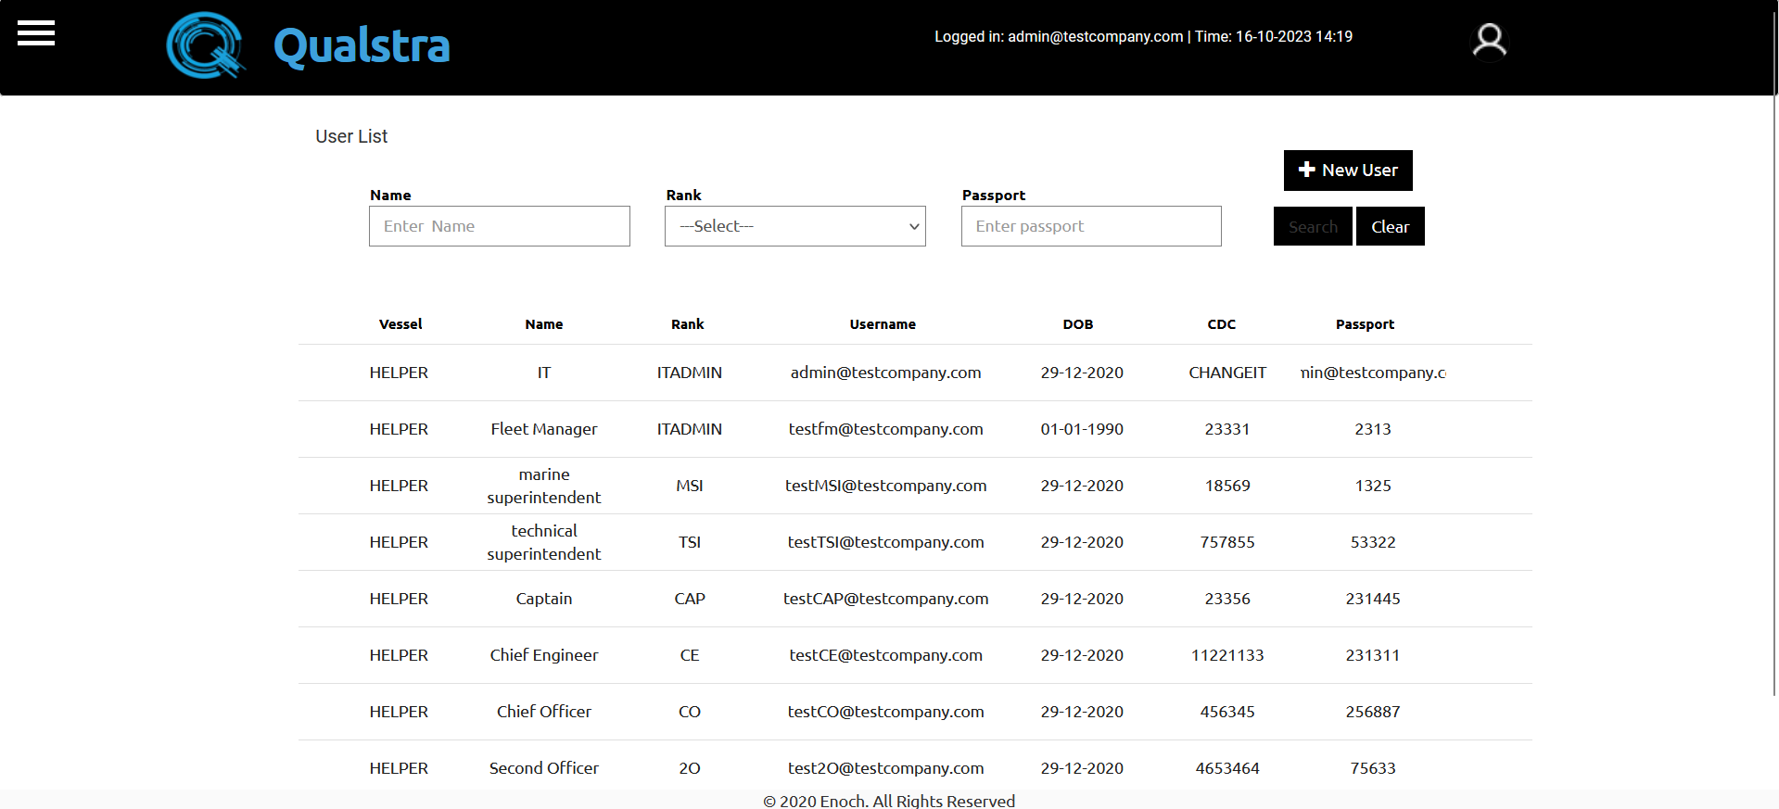

**To Go Home Page**

* Click the three-line Button at right top corner.



* You will have a Dropdown option.
* Click the Home Button.



* You will get home page.



# Role

* Click the Role Icon to enter to role page



* You will arrive at this page; here, click the 'Role' toggle bar.

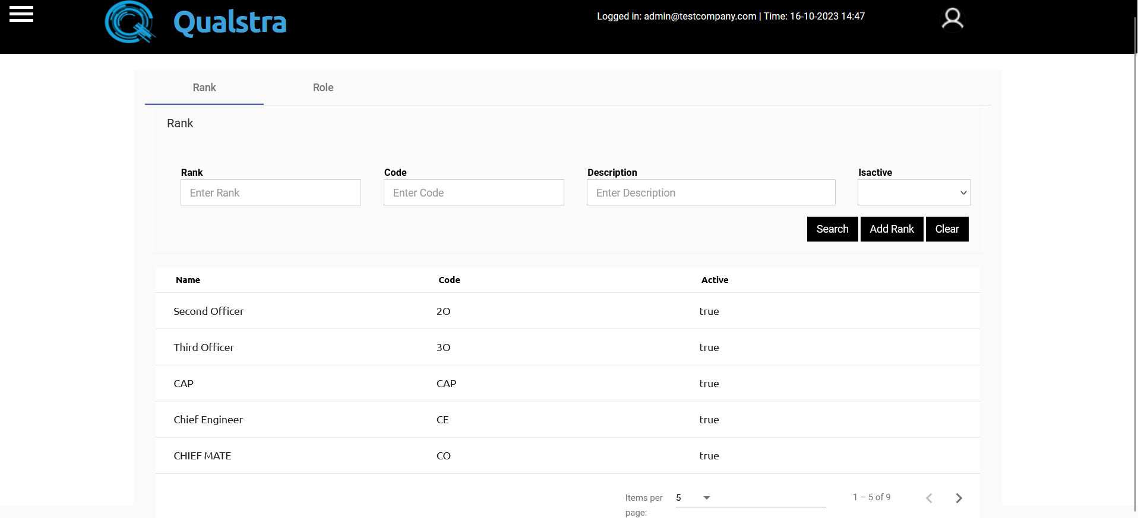

* After clicking on 'Role', you will be directed to this page

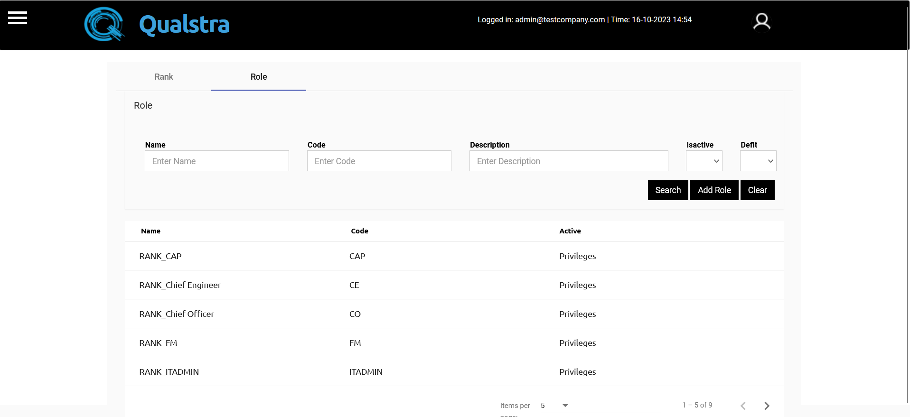

**To add new the role.**

* To add a new role, enter the name in the name block
* Enter the code in the code box.
* Enter the description in the description box.
* Enable “Isactive” or “Deflt” as required.
* After setting all, click the 'Add Role' button.

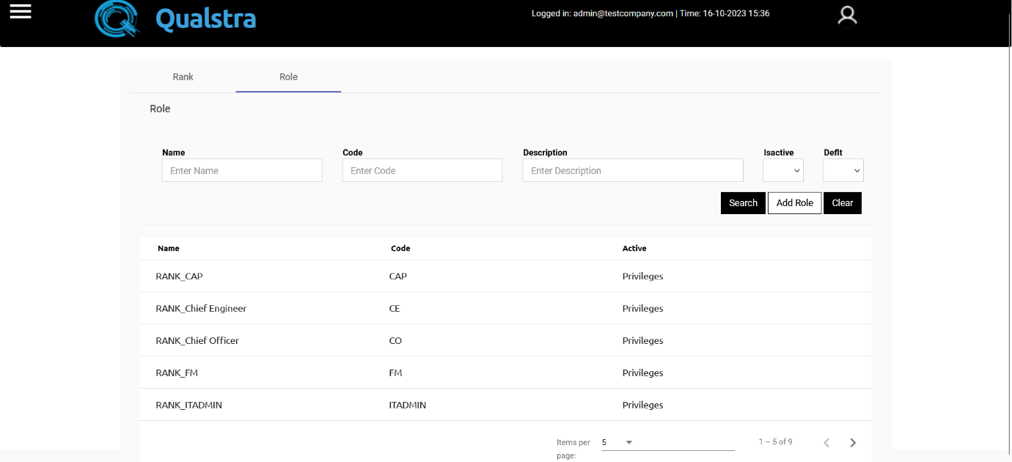

**To modify the roles and privilege access.**

* 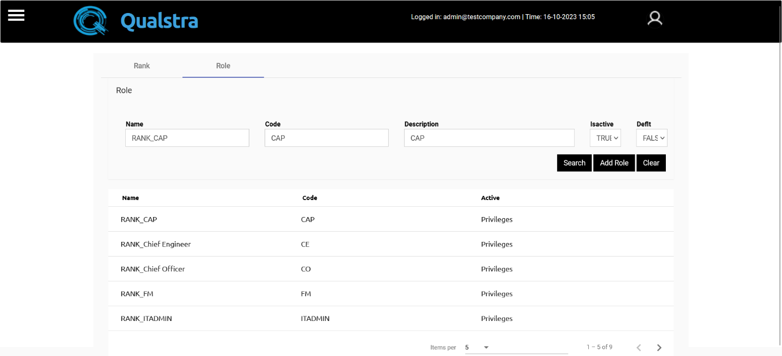Click on the privileges for the user whose name you want to change.
* After clicking on 'privileges', this page will appear.

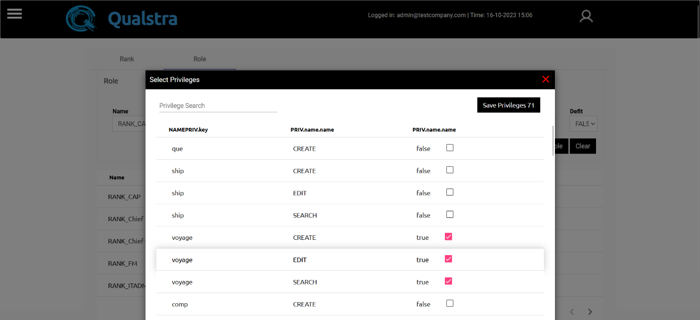

* On the privileges page, you can identify the access levels to be granted to this user.
* You can enable or disable them by checking the corresponding checkboxes next to each access entry.
* After selecting the access, click on 'Save Privileges'.